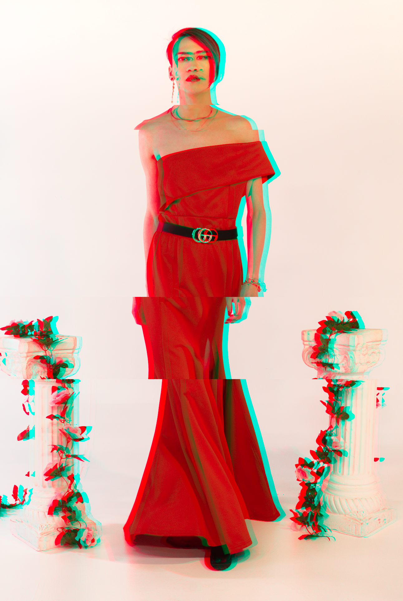
BRAZN is a hyperpop artist and producer based in Philadelphia. Combining experimental and commercial pop elements, they make music that highlights the emotions you feel throughout the queer experience - sadness, euphoria, confidence, and vulnerability. As a queer person themself, they strive to empower the listener to be different and stand out from the crowd. Their music ranges from topics of embracing emotional vulnerability to chasing a confident, carefree life interlaced with hypnotic melodies that will have anyone up and dancing.
They developed a passion for music and performing at a young age by participating in musicals, choirs, and fronting different bands. They began writing songs at the age of 12, drawing inspiration through their exploration of life. Later, this evolved into discovering an additional love for production and sound design that mirrors their eclectic androgynous style.
They have a variety of musical inspirations they draw from, which include Troye Sivan, Charli XCX, and Lady Gaga. They released three singles, “ANDRO”, “BLUE RASPBERRY,” and "Sunglasses" in 2021-2022. These songs will be included in their new EP with the release date TBD.

